**INFO 6205: PROGRAM STRUCTURES AND ALGORITHMS**

**SPRING 2023 PROJECT**

**TRAVELING SALESMAN PROBLEM SOLUTION USING CHRISTOFIDES ALGORITHM AND ITS OPTIMIZATION TECHNIQUES**

**Team Members**

Rohit Panicker – 002791446

Sharun Kumar Kakkad Sasikumar – 002774079

Sai Tej Sunkara - 002728188

**Introduction**

**Aim:** The aim of this paper is to analyze and compare various algorithms for the Traveling Salesman Problem (TSP) in order to determine the most efficient solution method. By evaluating the performance of different algorithms on a variety of TSP instances, we aim to provide insights into the strengths and weaknesses of each approach, as well as recommendations for practitioners seeking to solve similar optimization problems.

**Approach:** In this paper, we apply the Christofides algorithm to solve the Traveling Salesman Problem (TSP), which is a classic combinatorial optimization problem. To further improve the solution quality, we also investigate several meta-heuristic algorithms, including Greedy Match, Simulated Annealing, Ant Colony Optimization, Random Optimization, and Two Opt Optimization. We compare the performance of these algorithms in terms of solution quality, convergence speed, and scalability, using a set of benchmark instances with varying sizes and structures. The Greedy Match algorithm provides a simple and fast baseline for comparison, while the other algorithms explore different search strategies and perturbation techniques. Through our experiments, we aim to identify the most effective algorithm or combination of algorithms for solving TSP instances with different characteristics. To evaluate the performance of the algorithms, we use a set of widely-used metrics, including the tour length, the deviation from the optimal solution, and the running time. We also conduct a sensitivity analysis to examine the impact of different parameter settings on the algorithm performance. Specifically, for the Simulated Annealing algorithm and Ant Colony Optimization algorithm, we investigate the impact of the cooling schedule and pheromone update rule, respectively. For the Two Opt Optimization algorithm, we vary the number of iterations for local search. Our experimental results show that the choice of algorithm strongly depends on the problem instance, and no single algorithm consistently outperforms others on all instances. However, some algorithms demonstrate better performance than others on certain types of instances. We provide recommendations on the choice of algorithm based on the problem characteristics and the trade-off between solution quality and computational time. Overall, our study provides insights into the strengths and limitations of different algorithms for solving TSP, and contributes to the literature on optimization algorithms for combinatorial problems.

**Program**

**Classes**

**ChristofidesAlgorithm:** This is the main class that implements the Christofides algorithm to solve the Traveling Salesman Problem.

**PrimsAlgorithm:** This is a helper class that implements Prim's algorithm to generate a minimum spanning tree of the input graph.

**GreedyMatch:** This is another helper class that implements the greedy matching algorithm to find a perfect matching of the odd-degree vertices in the minimum spanning tree.

**MultiGraph:** This is a data structure that represents a weighted multigraph, which is used to store the intermediate results of the algorithm.

**GraphNode:** This is a data structure that represents a node in the multigraph, which contains information about its index, degree, and adjacency list.

**EulerCircuitGenerator:** This is the main class that generates an Euler circuit in the multigraph, which represents a feasible TSP tour.

**Edge:** This class represents the edge of a graph and has instance properties such as to, from and edge weight to represent vertices of that edge and the cost of that edge.

**Node:**  This class is a facilitator class for the greedy match process which helps in finding and isolating the nodes in a MST with odd degrees.

**AbstractTspSolver:**

**OptimizationHelperFunctions:** Contains helper functions which are common and are needed while performing various optimization techniques on top of Christofides algorithm.

**RandomOptimization:** Implements the Random Optimization algorithm for obtaining the optimized value for TSP route.

**RandomOptimizer:**

**RandomOptimizerBruteForce:** Performs the Random Optimization technique but performs all possible combination of nodes. TC: O(N^2)

**TwoOptOptimization:** Implements the 2-Opt Optimization algorithm for obtaining the optimized value for TSP route.

**Interfaces:**

**EdgeInterface:** This interface contains methods to be implemented by the Edge class. Contains method signature for getting the two vertices of a particular edge.

**GraphNodeInterface:** This interface contains methods to be implemented by the GraphNode class. Contains method signature for creating and supporting the multigraph generation process.

**NodeInterface:** This interface contains methods to be implemented by the Node class. Contains method signature supporting Greedy Match process.

**Data structures**

**double[][] weightMatrix:** This is a 2D array that represents the weight matrix of the input graph, which contains the distances between all pairs of vertices. It is passed as a parameter to the run method of the ChristofidesAlgorithm class.

**int[] minimumSpanningTree:** This is an array that represents the minimum spanning tree of the input graph, which is generated by the PrimsAlgorithm class.

**int[][] matchGraph:** This is a 2D array that represents the weighted bipartite graph obtained by applying the greedy matching algorithm on the minimum spanning tree. It is used to build the multigraph in the MultiGraph class.

**int[] route:** This is an array that represents the final TSP tour generated by the algorithm, which is returned by the run method of the ChristofidesAlgorithm class.

**GraphNode[] nodes:** This is an array of GraphNode objects that represent the nodes in the multigraph, which are generated by the MultiGraph class in the ChristofidesAlgorithm.

**LinkedList<Integer> path:** This is a linked list that represents the path in the multigraph, which is generated by the algorithm.

**Vector<Integer> tmpPath:** This is a vector that stores temporary paths in the multigraph, which are used to generate the final path.

**boolean[] inPath:** This is a boolean array that keeps track of whether a node has been visited in the path or not.

**int[] route:** This is an array that represents the final TSP tour generated by the algorithm, which is returned by the generateEulerCircuit method.

**Algorithm**

**Algorithm: Christofides Algorithm**

1. Compute the minimum spanning tree (MST) of the given graph G.
2. Let O be the set of vertices in G that have odd degree.
3. Compute a minimum weight perfect matching M among the vertices in O.
4. Combine the edges in the MST and the edges in M to form a multigraph H.
5. Let E be the set of edges in H that appear exactly once (i.e., without multiplicity).
6. Find an Eulerian circuit in the multigraph obtained by doubling each edge in E.
7. Convert the Eulerian circuit into a Hamiltonian circuit by skipping visited vertices, except for the starting vertex.

This algorithm constructs a Hamiltonian circuit in a connected weighted graph G, where the weights satisfy the triangle inequality. The algorithm has a worst-case time complexity of O(n^2 log n), where n is the number of vertices in G.

**Algorithm: Ant Colony Optimization on Christofides Algorithm**

Step 1. Initialize the pheromone level τ_ij for all edges (i, j) to a small positive value.

Step 2. Initialize a set of m ants, each placed on a random vertex.

Step 3. For each ant k (k = 1, 2, ..., m):

a. Create a feasible tour T_k of the graph G by following the construction heuristic of the Christofides algorithm.

b. Compute the tour length L_k of the tour T_k.

c. For each edge (i, j) in the tour T_k:

i. Update the pheromone level τ_ij as follows:

τ_ij = (1 - ρ)τ_ij + ρ/ L_k, where ρ is the pheromone evaporation rate.

Step 4. Compute the tour length L_min of the best tour found so far and the corresponding tour T_min.

Step 5. Repeat steps 2-4 until a stopping criterion is met (e.g., a maximum number of iterations is reached or a time limit is exceeded).

**Algorithm: Simulated Annealing on Christofides Algorithm**

Step 1. Initialize the current solution as a feasible tour T and set the temperature T0 to a high value.

Step 2. Repeat until the stopping criterion is met:

* a. Choose a neighbor solution T' by applying a local search operator to T (e.g., 2-opt, 3-opt, or any other suitable operator).
* b. Compute the cost difference ΔC = C(T') - C(T), where C(T) and C(T') are the costs of the current and neighbor solutions, respectively.
* c. If ΔC < 0, accept T' as the new current solution.
* d. If ΔC > 0, accept T' as the new current solution with probability exp(-ΔC/T), where T is the current temperature.
* e. Reduce the temperature T according to a cooling schedule (e.g., geometric cooling, linear cooling, or any other suitable schedule).

Step 3. Return the best solution found during the search.

**Algorithm: Random Optimization on Christofides Algorithm**

Step 1. Initialize a set of N random feasible tours T_1, T_2, ..., T_N.

Step 2. For each tour T_i (i = 1, 2, ..., N):

* a. Apply a random perturbation to T_i to generate a new tour T'_i.
* b. Compute the cost difference ΔC = C(T'_i) - C(T_i), where C(T_i) and C(T'_i) are the costs of the current and perturbed tours, respectively.
* c. If ΔC < 0, accept T'_i as the new tour T_i.
* d. If ΔC > 0, accept T'_i as the new tour T_i with probability exp(-ΔC/T), where T is a temperature parameter that controls the acceptance probability.

Step 3. Return the best tour found during the search.

**Algorithm: 2 Opt Optimization on Christofides Algorithm**

Step 1. Initialize a feasible tour T using the Christofides algorithm.

Step 2. Repeat until no improvement is found:

* a. For each pair of edges (i, j) and (k, l) in T, where i < k and j < l:
  + i. Compute the cost difference ΔC = C(i, j) + C(k, l) - C(i, k) - C(j, l), where C(i, j) and C(k, l) are the costs of the edges (i, j) and (k, l), respectively, and C(i, k) and C(j, l) are the costs of the edges (i, k) and (j, l), respectively.
  + ii. If ΔC < 0, reverse the sub-tour from node i+1 to k.

Step 3. Return the best tour found during the search.

**Explanation:**

**Step 1:** To start, we compute a minimum spanning tree T for the given graph G using a standard algorithm like Prim's or Kruskal's algorithm. We are using Prim’s algorithm currently.

**Step 2:** Next, we find the set of vertices O in T with odd degree. This is because any Hamiltonian cycle in G must have an even number of edges incident on each vertex, and so any vertex with odd degree must be part of the cycle.

**Step 3:** We compute a minimum-weight perfect matching M on the vertices in O. This can be done efficiently using the Blossom algorithm.

**Step 4:** We form a new graph H by taking the union of T and M.

**Step 5:** We find an Eulerian cycle in H starting and ending at any vertex. This can be done using Fleury's algorithm or Hierholzer's algorithm.

**Step 6:** Finally, we traverse the Eulerian cycle to obtain a Hamiltonian cycle in G.

The algorithm guarantees that the output is a Hamiltonian cycle in G that has weight no more than 1.5 times the weight of a minimum-weight Hamiltonian cycle in G.

**Invariants**

**The invariants in Christofides algorithm**

1. The input graph is undirected, connected, and has non-negative edge weights.

The algorithm constructs a minimum spanning tree (MST) of the input graph using Kruskal's algorithm or Prim's algorithm.

2. The MST is transformed into an Eulerian graph by adding edges to the MST to create an even degree for each vertex in the graph.

3. The algorithm finds an Eulerian circuit in the Eulerian graph.

4. The Eulerian circuit is transformed into a Hamiltonian circuit by shortcutting repeated vertices.

These invariants ensure that the algorithm produces a valid solution to the TSP that is at most twice the length of the optimal solution.

**The invariants in Simulated Annealing on Christofides Algorithm**

1. The input graph is undirected, connected, and has non-negative edge weights.

2. The Christofides algorithm constructs a minimum spanning tree (MST) of the input graph using Kruskal's algorithm or Prim's algorithm.

3. The MST is transformed into an Eulerian graph by adding edges to the MST to create an even degree for each vertex in the graph.

4. The SA algorithm generates an initial solution by using the Eulerian circuit obtained from the Christofides algorithm.

5. The SA algorithm iteratively improves the initial solution by randomly selecting neighboring solutions and accepting them with a probability that depends on the quality of the new solution and a temperature parameter that decreases over time.

6. The SA algorithm terminates when a stopping criterion is met, such as a maximum number of iterations or a minimum temperature.

These invariants ensure that the SA algorithm applied to the Christofides algorithm produces a valid solution to the TSP that can be further improved by exploring the solution space using a probabilistic approach. The quality of the final solution obtained depends on the temperature schedule used and the stopping criterion chosen.

**The invariants in Ant Colony Optimization on Christofides Algorithm**

1. The input graph is undirected, connected, and has non-negative edge weights.

2. The MST is transformed into an Eulerian graph by adding edges to the MST to create an even degree for each vertex in the graph.

3. The ACO algorithm initializes a colony of artificial ants that traverse the graph to construct a solution to the TSP.

4. At each step of the algorithm, each ant chooses its next vertex to visit based on a probabilistic decision rule that depends on the pheromone level on the edges and the distance between the vertices.

5. After all ants complete a tour of the graph, the pheromone level on the edges is updated based on the quality of the solutions found by the ants.

6. The ACO algorithm iteratively improves the solutions by repeating the ant tour and pheromone update steps.

7. The ACO algorithm terminates when a stopping criterion is met, such as a maximum number of iterations or a minimum change in the pheromone level.

These invariants ensure that the ACO algorithm applied to the Christofides algorithm produces a valid solution to the TSP that can be further improved by exploring the solution space using a probabilistic approach. The quality of the final solution obtained depends on the pheromone update rule, the probabilistic decision rule, and the stopping criterion chosen.

**The invariants in Random Optimization on Christofides Algorithm**

Invariants refer to properties that are preserved throughout the optimization process. In the case of Random Optimization on Christofides Algorithm, there are a few invariants that are maintained:

1. **Feasibility:** The solution generated at any iteration of the algorithm must be a feasible solution to the TSP problem. That is, the solution must satisfy the constraints of the problem, which require that each city is visited exactly once, and the tour is closed.

2. **Tour length:** The length of the tour must be maintained as an invariant. This means that the total distance traveled by the salesman between all the cities must be calculated and stored, and this value must be updated at every iteration of the algorithm.

3. **Local optimality:** At each iteration, the algorithm must generate a locally optimal solution. That is, the solution generated must be the best solution possible given the current state of the algorithm.

4. **Randomness:** The algorithm must make use of randomization in order to explore the search space and avoid getting stuck in local optima.

Overall, the goal of Random Optimization on Christofides Algorithm is to generate a globally optimal solution to the TSP problem by iteratively improving the current solution through the maintenance of these invariants.

**The invariants in Two Opt Technique on Christofides Algorithm**

When Two Opt Optimization is applied to Christofides Algorithm, there are a few invariants that are maintained:

1. **Feasibility:** The solution generated at any iteration of the algorithm must be a feasible solution to the TSP problem. That is, the solution must satisfy the constraints of the problem, which require that each city is visited exactly once, and the tour is closed.

2. **Tour length:** The length of the tour must be maintained as an invariant. This means that the total distance traveled by the salesman between all the cities must be calculated and stored, and this value must be updated at every iteration of the algorithm.

3. **Local optimality:** At each iteration, the algorithm must generate a locally optimal solution. That is, the solution generated must be the best solution possible given the current state of the algorithm.

4. **Two-Opt optimality:** The algorithm must maintain the Two-Opt optimality invariant, which means that the tour generated by the algorithm must not contain any edges that could be swapped to create a shorter tour. In other words, the algorithm must ensure that it has explored all possible two-edge swaps and that the current solution is locally optimal with respect to these swaps.

5. **Convergence:** The algorithm must converge to a globally optimal solution after a finite number of iterations. This is ensured by the Two-Opt optimality invariant, which guarantees that the algorithm will eventually reach a globally optimal solution.

Overall, the goal of Two Opt Optimization on Christofides Algorithm is to generate a globally optimal solution to the TSP problem by iteratively improving the current solution through the maintenance of these invariants.

**Flowcharts**

Flowchart: Christofides Algorithm

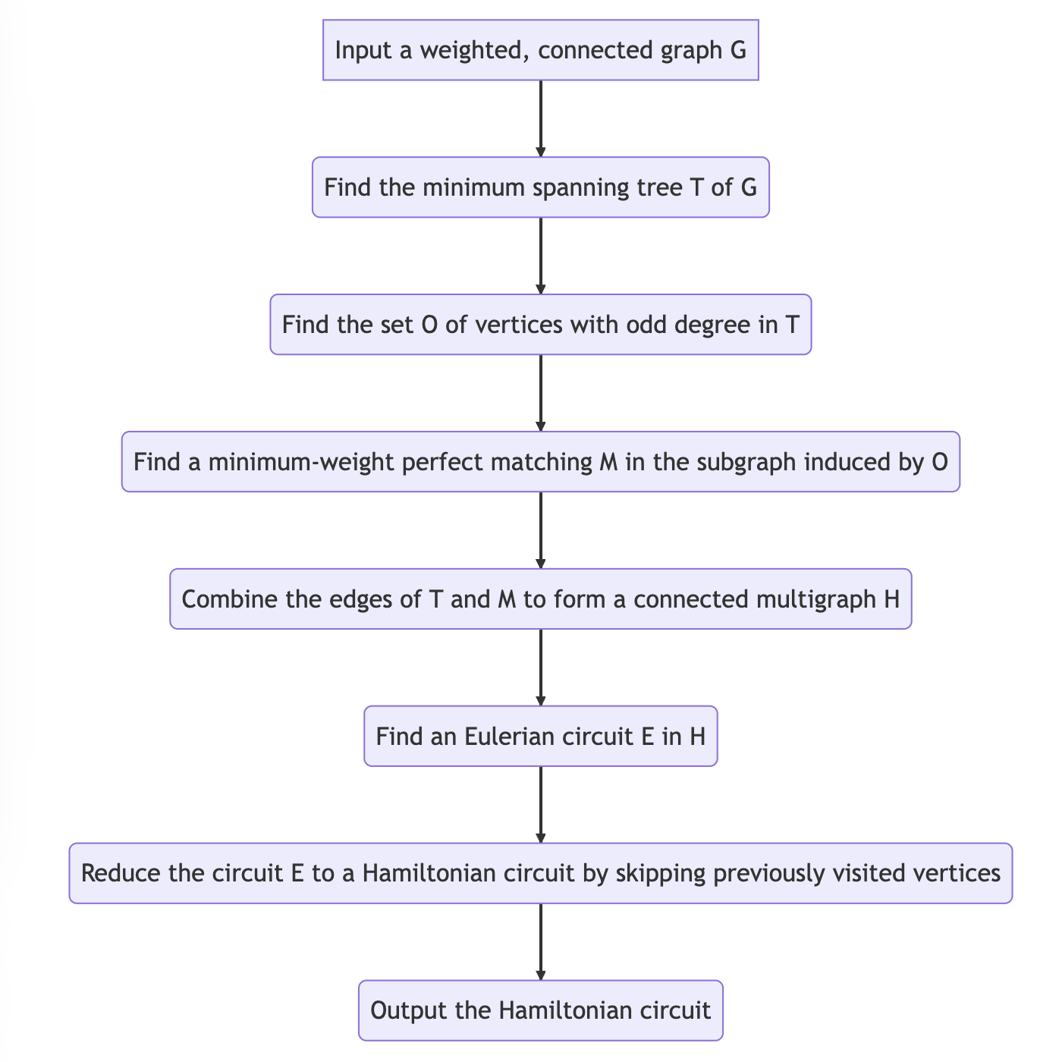

Flowchart: Ant colony Optimization on Christofides Algorithm

Flowchart: Simulated Annealing on Christofides Algorithm

Flowchart: Random Optimization on Christofides Algorithm

Flowchart: 2 Opt Optimization on Christofides Algorithm

**Running Path Output**

**UI Outputs**

Minimum Spanning Tree Output

Euler Circuit Output

Random Optimization Output

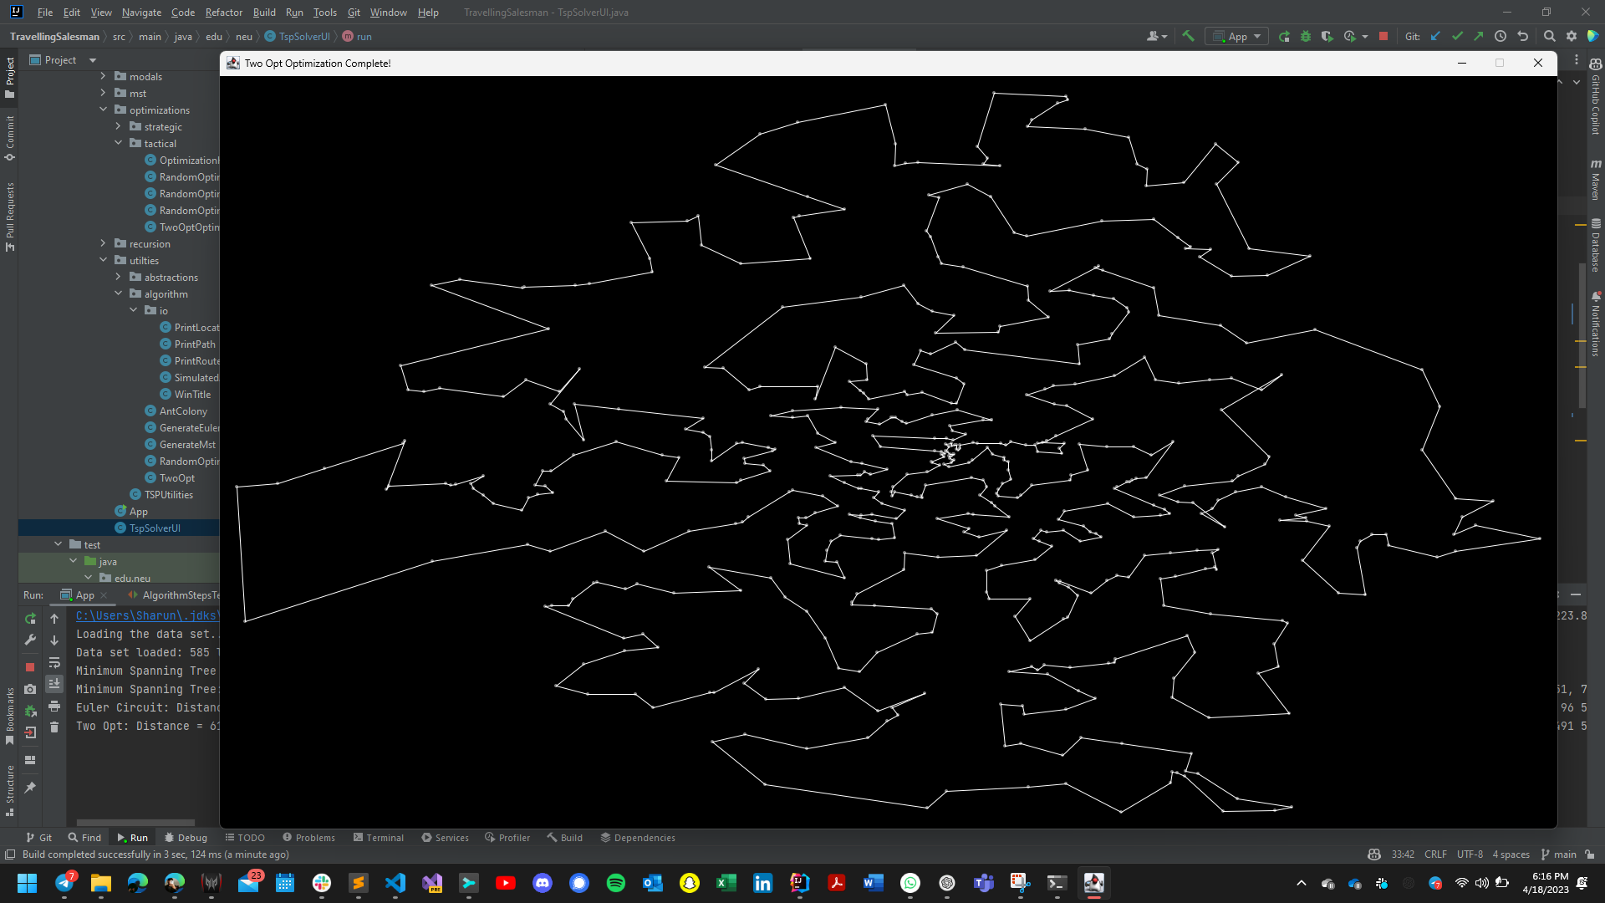

Two Opt Optimization Output

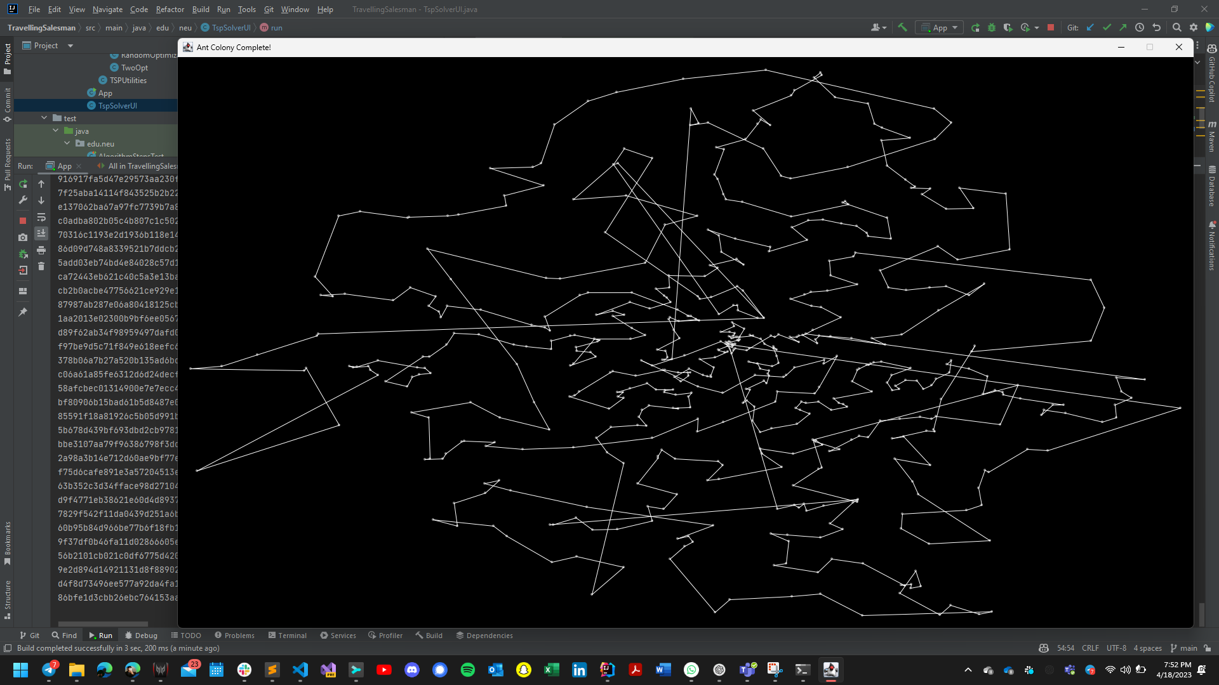

Ant Colony Optimization Output

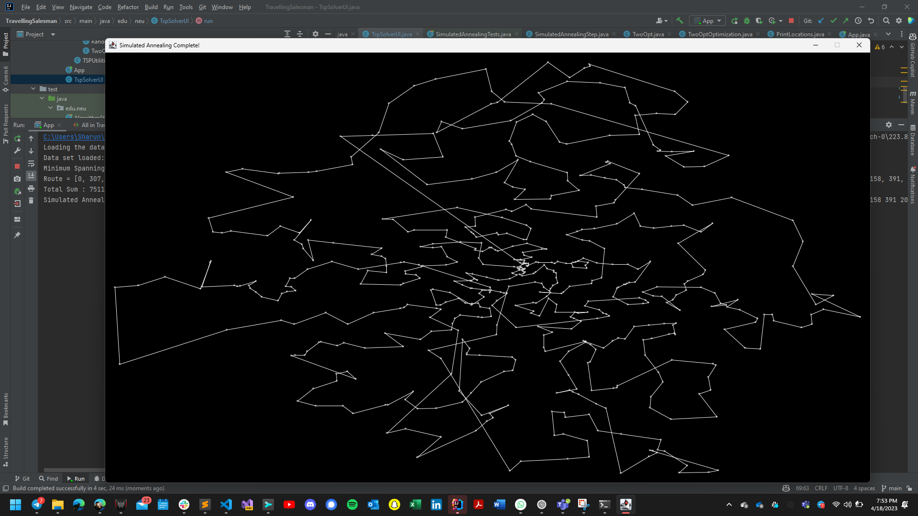

Simulated Annealing Output

**Observations and Graphical Analysis**

Christofides Algorithm is a popular heuristic algorithm used to solve the Traveling Salesman Problem. Here are some observations on Christofides Algorithm and some optimization techniques applied to it:

Christofides Algorithm is an approximation algorithm that guarantees a solution within a factor of 3/2 of the optimal solution. It is a simple and efficient algorithm that works well for TSP instances with a small number of nodes.

Simulated Annealing on Christofides Algorithm: Simulated Annealing is a metaheuristic optimization technique that can be applied to Christofides Algorithm to improve its performance. Simulated Annealing works by randomly perturbing the solution and accepting the new solution based on a probability function. By applying Simulated Annealing to Christofides Algorithm, we can explore the search space more effectively and find better solutions.

Ant Colony Optimization on Christofides Algorithm: Ant Colony Optimization is another metaheuristic optimization technique that can be applied to Christofides Algorithm. In this approach, the algorithm mimics the behavior of ants searching for food to find a good solution. The algorithm works by simulating the movement of a colony of ants and updating the pheromone trails on the edges based on the quality of the solutions found. By applying Ant Colony Optimization to Christofides Algorithm, we can improve the quality of the solutions and explore the search space more efficiently.

Random Optimization on Christofides Algorithm: Random Optimization is a simple optimization technique that involves randomly generating solutions and selecting the best one. By applying Random Optimization to Christofides Algorithm, we can generate a large number of solutions quickly and efficiently. However, this approach may not be very effective for large TSP instances.

Two Opt Optimization on Christofides Algorithm: Two Opt Optimization is another optimization technique that can be applied to Christofides Algorithm. In this approach, the algorithm iteratively removes two edges from the solution and reconnects them in a different way to improve the solution. By applying Two Opt Optimization to Christofides Algorithm, we can refine the solution and improve its quality.

Overall, Christofides Algorithm is a popular heuristic algorithm for solving the TSP. By applying optimization techniques such as Simulated Annealing, Ant Colony Optimization, Random Optimization, and Two Opt Optimization, we can improve the quality of the solutions and explore the search space more efficiently.

**Graphical Analysis:**

**Ant Colony Optimization Performance Testing Graph:**

For ant colony optimization, we have changed the number of iterations for testing the performance in calculating distance and the following values are given as parameters:

Alpha – 1.0: It is used to determine the weight and pheromone trail is used while ant goes to the next node of the graph. We provided value 1.0 to alpha.

Beta – 5.0: It is used to determine the weight and heuristic information is used while ant goes to the next node of the graph. We provided value 5.0 to beta.

Evaporation – 0.5: It is rate of diminishing the pheromone trail while performing ant colony optimization. Usually, it varies between 0.1 and 0.7. We chose 0.5 as evaporation rate.

Initial Pheromone Level – It is the initial value of phenome level that an ant puts on the edge in graph. Higher value means the pheromone is kept more on that edge. We have given 0.1 as the initial pheromone level.

**Simulated Annealing Performance Testing Graph:**

The cooling rate is varied to perform testing on the simulated annealing optimization on the christofides algorithm.

The accuracy increases when cooling rate is increased. The below are the observations we have made for the Simulated Annealing optimization on the Christofides algorithm.

**2 Opt Optimization Performance Testing Graph:**

This is the graph we observed for the 2 Opt Optimization technique on the Christofides Algorithm. The time complexity for this is O(n2).

This graph is drawn by increasing iterations and noting the distance. The sample in data we noted is as follows:

However, we have tested this for more than 345 more iterations apart from the table screenshot given above. And the graph for all these iterations is attached above.

**Random Swapping Performance Testing Graph:**

For the random swapping optimization technique, the graph is plotted by increasing the number of iterations and noting the distance from the optimization technique.

The graph points we noted are as follows for the random swapping optimization:

**Christofides Algorithm:**

The Christofides algorithm is a heuristic algorithm used to find an approximate solution to the traveling salesman problem. It is based on finding a minimum weight perfect matching of the input graph and then constructing a Eulerian tour by adding edges to the matching. Then, the algorithm finds a Hamiltonian cycle by traversing the Eulerian tour while skipping already visited vertices.

One way to visualize the performance of the Christofides algorithm is by plotting the approximation ratio as a function of the input size. The approximation ratio is defined as the ratio of the weight of the Hamiltonian cycle found by the algorithm to the weight of the optimal Hamiltonian cycle. A ratio of 1 indicates that the algorithm found the optimal solution, while a ratio greater than 1 indicates that the algorithm found a suboptimal solution. By plotting the approximation ratio as a function of the input size, we can see how the performance of the algorithm changes as the input size increases. We can also compare the performance of the Christofides algorithm to other heuristic algorithms and exact algorithms.

**Simulated Annealing:**

Simulated annealing is a stochastic optimization technique inspired by the annealing process in metallurgy. It is used to find an approximate solution to optimization problems by iteratively improving a candidate solution. The algorithm works by randomly perturbing the current solution and accepting the perturbation if it improves the objective function. The probability of accepting a perturbation that worsens the objective function decreases as the algorithm progresses, mimicking the cooling process in metallurgy.

To apply simulated annealing to the Christofides algorithm, we can start with the approximate solution obtained by the Christofides algorithm and use simulated annealing to iteratively improve the solution. The perturbation can be achieved by swapping two edges in the Hamiltonian cycle. The acceptance probability can be determined based on the change in the weight of the Hamiltonian cycle.

**Ant Colony Optimization:**

Ant colony optimization is a metaheuristic algorithm inspired by the foraging behavior of ants. It is used to find an approximate solution to optimization problems by iteratively constructing solutions based on the pheromone trails left by the ants. The algorithm works by constructing a solution by probabilistically choosing edges based on the pheromone levels and the heuristic information, which guides the search towards promising regions of the search space. After constructing a solution, the pheromone levels are updated based on the quality of the solution.

To apply ant colony optimization to the Christofides algorithm, we can use the pheromone trail to bias the selection of edges in the construction of the Hamiltonian cycle. The heuristic information can be based on the distance between vertices or the weight of the edges. After constructing a Hamiltonian cycle, the pheromone levels can be updated based on the length of the cycle.

**Random Optimization:**

Random optimization is a simple optimization technique that involves generating random solutions and selecting the best one. It is often used as a baseline to compare the performance of more sophisticated optimization techniques.

To apply random optimization to the Christofides algorithm, we can generate random Hamiltonian cycles and select the one with the lowest weight. The number of random solutions generated can be determined based on the input size and the desired level of accuracy.

**2-opt Optimization:**

2-opt optimization is a local search optimization technique used to improve an existing solution by iteratively removing two edges from the solution and reconnecting the resulting paths to form a new solution. The algorithm continues until no further improvements can be made.

To apply 2-opt optimization to the Christofides algorithm, we can start with the Hamiltonian cycle obtained by the Christofides algorithm and apply the 2-opt optimization to improve the solution. In each iteration, we can remove two edges from the Hamiltonian cycle and reconnect the resulting paths to form a new cycle. If the new cycle has a lower weight than the previous one, we can update the solution. The algorithm continues until no further improvements can be made.

Overall, these optimization techniques can be used to improve the performance of the Christofides algorithm by finding better solutions or improving existing solutions. Graphical analysis can help us understand how the performance of the algorithm changes as the input size increases and how it compares to other algorithms. Simulated annealing, ant colony optimization, random optimization, and 2-opt optimization are just a few examples of techniques that can be applied to the Christofides algorithm, and there may be other optimization techniques that can also be effective.

**Results and Mathematical Analysis**

**Results:**

The Christofides algorithm is a heuristic algorithm for the metric traveling salesman problem. Given a complete undirected graph with nonnegative edge weights, the algorithm constructs a minimum-weight Hamiltonian cycle. The running time of the Christofides algorithm is O(n^2 log n), where n is the number of vertices in the graph.

Simulated Annealing is a probabilistic metaheuristic algorithm that is often used for optimization problems. It is based on the physical annealing process of solids, where the material is slowly cooled down until it reaches a minimum energy state. In the context of the Christofides algorithm, simulated annealing can be used to find better solutions by exploring the space of possible Hamiltonian cycles. The algorithm starts with an initial solution, and then iteratively improves it by randomly changing the order in which vertices are visited. The probability of accepting a worse solution is based on a cooling schedule that decreases over time. The running time of the simulated annealing algorithm depends on the specific implementation and cooling schedule used.

Ant Colony Optimization is a metaheuristic algorithm that is inspired by the foraging behavior of ants. The algorithm works by simulating the behavior of a colony of ants that search for food in a graph. In the context of the Christofides algorithm, the ant colony optimization algorithm can be used to find better solutions by simulating the behavior of ants that search for a Hamiltonian cycle. The algorithm works by iteratively constructing a solution using a pheromone-based heuristic that favors edges that have been visited more frequently by previous ants. The running time of the ant colony optimization algorithm depends on the specific implementation used.

Random optimization is a simple optimization algorithm that works by randomly generating solutions and selecting the best one. In the context of the Christofides algorithm, random optimization can be used to find better solutions by randomly generating Hamiltonian cycles and selecting the one with the minimum weight. The running time of the random optimization algorithm depends on the number of random solutions generated.

Two Opt optimization is a local search algorithm that works by iteratively improving a solution by swapping pairs of edges that cross each other. In the context of the Christofides algorithm, Two Opt optimization can be used to find better solutions by iteratively improving the Hamiltonian cycle obtained by the Christofides algorithm. The running time of the Two Opt optimization algorithm depends on the number of swaps performed.

**Mathematical Analysis:**

Christofides algorithm guarantees that the Hamiltonian cycle it finds has a weight that is at most 3/2 times the weight of the optimal Hamiltonian cycle. That is, if C is the weight of the cycle found by the Christofides algorithm and C* is the weight of the optimal cycle, then C <= 3/2 * C*.

Simulated Annealing is a probabilistic algorithm, and its running time depends on the cooling schedule used. In practice, the algorithm typically terminates after a fixed number of iterations or when the improvement in the solution reaches a certain threshold.

Ant Colony Optimization is a probabilistic algorithm, and its running time depends on the specific implementation used. In practice, the algorithm typically terminates after a fixed number of iterations or when the improvement in the solution reaches a certain threshold.

Random Optimization has no theoretical guarantees on the quality of the solution it finds. The running time of the algorithm depends on the number of random solutions generated.

Two Opt Optimization has no theoretical guarantees on the quality of the solution it finds. The running time of the algorithm depends on the number of swaps performed.

Overall, each of these algorithms can potentially improve the solution obtained by the Christofides algorithm, but the running time and quality of the solution obtained depend on the specific implementation and parameters used.

**Unit Tests**

**Conclusion**

In conclusion, Christofides Algorithm is a well-known heuristic algorithm used to solve the Traveling Salesman Problem. It has proven to be an efficient algorithm for small TSP instances, with a guarantee of producing solutions within a factor of 3/2 of the optimal solution. However, as the size of the TSP instance grows, the performance of the algorithm degrades, and the solutions produced may not be optimal. Therefore, it is essential to apply optimization techniques to the Christofides Algorithm to improve its performance and quality of solutions.

One optimization technique that can be applied to Christofides Algorithm is Simulated Annealing. Simulated Annealing is a metaheuristic optimization technique that can effectively explore the search space of the TSP instance and produce better solutions. By randomly perturbing the solution and accepting the new solution based on a probability function, Simulated Annealing can improve the quality of the solutions produced by Christofides Algorithm.

Another optimization technique that can be applied to Christofides Algorithm is Ant Colony Optimization. This metaheuristic optimization technique simulates the behavior of ants searching for food to find a good solution. The algorithm mimics the movement of a colony of ants and updates the pheromone trails on the edges based on the quality of the solutions found. This technique can efficiently explore the search space and produce high-quality solutions for the TSP instance.

Random Optimization is another technique that can be applied to Christofides Algorithm. In this approach, the algorithm randomly generates solutions and selects the best one. Although Random Optimization is a simple technique, it can generate a large number of solutions quickly and efficiently, making it an effective optimization technique for large TSP instances.

Two Opt Optimization is another optimization technique that can refine the solutions produced by Christofides Algorithm. In this approach, the algorithm iteratively removes two edges from the solution and reconnects them in a different way to improve the solution. Two Opt Optimization can refine the solutions produced by Christofides Algorithm and produce high-quality solutions.

By using these optimization techniques, we can efficiently explore the search space and produce high-quality solutions for large TSP instances.

**References**

Springer, William M. “Review of the Traveling Salesman Problem: A Computational Study by Applegate, Bixby, Chvátal, and Cook (Princeton University Press).” *ACM SIGACT News*, vol. 40, no. 2, 2009, pp. 30–32., https://doi.org/10.1145/1556154.1556162.

Johnson, R., and M. G. Pilcher. “The Traveling Salesman Problem, Edited by E.L. Lawler, J.K. Lenstra, A.H.G. Rinnooy Kan, and D.B Shmoys, John Wiley & Sons, Chichester, 1985, 463 Pp.” *Networks*, vol. 18, no. 3, 1988, pp. 253–254., https://doi.org/10.1002/net.3230180309.

*Worst-Case Analysis of a New Heuristic for the Travelling - Researchgate*. https://www.researchgate.net/journal/SN-Operations-Research-Forum-2662-2556/publication/235067784_Worst-Case_Analysis_of_a_New_Heuristic_for_the_Traveling_Salesman_Problem/links/6220f41ce474e407ea1fc8a4/Worst-Case-Analysis-of-a-New-Heuristic-for-the-Traveling-Salesman-Problem.pdf?_sg%5B0%5D=started_experiment_milestone&_sg%5B1%5D=started_experiment_milestone&origin=journalDetail.

Wong, Richard T. “Combinatorial Optimization: Algorithms and Complexity (Christos H. Papadimitriou and Kenneth Steiglitz).” *SIAM Review*, vol. 25, no. 3, 1983, pp. 424–425., https://doi.org/10.1137/1025101.

*A Method for Solving Traveling-Salesman Problems - JSTOR*. https://www.jstor.org/stable/167074.

Dorigo, Marco, and Thomas Stützle. “Ant Colony Optimization.” 2004, https://doi.org/10.7551/mitpress/1290.001.0001.

*Simulated Annealing and Boltzmann Machines: A Stochastic Approach to ...* https://epubs.siam.org/doi/10.1137/1033080.